PROJECT REPORT
CSD301
(DESCRIPTIVE ANALYTICS PROJECT)
COMPUTER SCIENCE AND ENGINEERING


LOVELY PROFESSIONAL UNIVERSITY

Macro-Financial Dynamics and Crypto Asset Modeling
A Project Report Submitted for Academic Evaluation

Team Name: Data-Nomics
Member: Taranjeet Singh

ACKNOWLEDGEMENT
I would like to express my sincere gratitude to my faculty for providing me with the opportunity to undertake this project. Their continuous guidance and support played a crucial role in helping me understand complex financial concepts and apply them effectively. I also thank my institution for providing the necessary academic resources and environment to successfully complete this individual study.

ABSTRACT
The integration of cryptocurrencies into traditional financial markets has created an urgent need to empirically define their behavior under varying macroeconomic conditions. This independent study conducts a rigorous quantitative analysis of Bitcoin (BTC), Gold, and the S&P 500 against leading macroeconomic indicators, specifically the Consumer Price Index (CPI), Federal Funds Rate (FED_RATE), and the CBOE Volatility Index (VIX). Utilizing 12 years of daily financial data (2014–2026), this project systematically debunks prevalent market narratives, notably the classification of Bitcoin as an inflation hedge.
Through econometric techniques such as GARCH(1,1) volatility modeling, Augmented Dickey-Fuller stationarity tests, and Granger Causality analysis, the research quantifies the extreme tail risk and volatility clustering inherent in digital assets. Furthermore, ensemble machine learning algorithms (Random Forest) achieved an 89.49% accuracy in classifying market risk regimes based on these macro features. Ultimately, the study leverages Modern Portfolio Theory to map the Efficient Frontier and proposes a "Dynamic Macro Regime Strategy". This algorithmic framework proves that dynamically rotating capital based on real-time macro signals (such as rotating into Gold during VIX spikes) massively outperforms static buy-and-hold strategies, maximizing risk-adjusted returns while preventing catastrophic portfolio drawdowns.

TABLE OF CONTENTS
Contents
1.Introduction 5
2.Problem Statement 5
3. Objectives 6
4. Scope of the Study 6
4.1 Time Horizon 6
4.2 Asset Universe 7
4.3 Macroeconomic Indicators 7
5. COLUMN DESCRIPTION 7
6. METHODOLOGY 8
6.1 Frequency Alignment and Imputation 8
6.2 Logarithmic Return Transformation 8
6.3 Stationarity Testing: Augmented Dickey-Fuller (ADF) 8
7.Exploratory Data Analysis and Distribution Mapping 10
7.1 Distribution Moments: Skewness and Kurtosis 10
7.2 Maximum Drawdown Analysis 10
8. Advanced Risk and Volatility Profiling 11
8.1 Volatility Clustering and GARCH(1,1) 11
8.2 Tail Risk: Value at Risk (VaR) and Conditional VaR (CVaR) 12
8.3 Risk-Adjusted Returns (Sharpe and Sortino Ratios) 12
9. Macroeconomic Correlation and Causality 12
9.1 The Inflation Hedge Fallacy 13
9.2 The "Digital Gold" Safe Haven Test 13
10. Machine Learning and Predictive Analytics 14
10.1 Predictive Forecasting 14
10.2 Regime Classification and Feature Importance 14
11. Modern Portfolio Theory and Optimization 15
11.1 The Minimum Variance Portfolio (The Safest Route) 15
11.2 The Maximum Sharpe Ratio Portfolio (The Optimal Route) 15
12. Dynamic Regime Strategy and Financial Insights 16
12.1 The Algorithmic Ruleset 16
12.2 The Ultimate Backtest 17
13. Deployment: Interactive Financial Intelligence Dashboard 17
13.1 Overview and Architecture 17
13.2 Algorithmic Rule-Based Insights 18
13.3 Core Analytical Modules 18
14.Key Findings 19
15.Conclusion 20
16.Hypothetical Investment Scenario 20
16.1 The Conservative Framework (Capital Preservation) 20
16.2 The Moderate Framework (Risk Parity & Balanced Growth) 20
16.3 The Aggressive Framework (Wealth Acceleration) 21
17.Recommendations 21
18.Future Scope 21

1.Introduction
The global financial ecosystem has undergone a massive paradigm shift over the past decade. Historically, portfolio construction relied heavily on the dichotomy between equities (representing economic growth) and bonds or precious metals (representing risk-off safety). The introduction and subsequent maturation of decentralized digital assets—most notably Bitcoin (BTC)—has introduced an entirely new asset class to the market.
Bitcoin's rise from an obscure digital token to a trillion-dollar asset class has sparked intense debate among institutional investors, quantitative researchers, and retail traders. Proponents often label Bitcoin as "digital gold," theorizing that its strictly capped supply of 21 million coins makes it an ultimate hedge against fiat currency debasement and central bank money printing. Conversely, skeptics argue that Bitcoin behaves as a hyper-volatile, long-duration technology stock, highly sensitive to interest rates and overall market liquidity.
Adding to this complexity is the highly volatile macroeconomic environment observed between 2020 and 2026. The COVID-19 pandemic necessitated unprecedented monetary stimulus, driving the Federal Funds Rate to near-zero levels. This was rapidly followed by a severe inflationary spike, forcing central banks into aggressive quantitative tightening. In this environment, understanding the true drivers of asset prices is no longer optional; it is imperative for capital survival.
This comprehensive study leverages over a decade of daily financial data to systematically strip away the narratives surrounding Bitcoin, Gold, and the S&P 500, replacing them with rigorous, empirical, and mathematically sound conclusions.

2.Problem Statement
Modern asset management faces a critical vulnerability: Static portfolio allocations fail in dynamic macroeconomic regimes.
The traditional "60/40" portfolio (60% equities, 40% bonds) was designed for an era of stable inflation and predictable interest rates. However, when inflation spikes (CPI) or market fear accelerates (VIX), static portfolios suffer catastrophic, correlated drawdowns. Furthermore, the integration of Bitcoin into institutional portfolios is hindered by a lack of quantitative clarity regarding its actual risk profile and its behavioral shifts during varying economic cycles.
Specifically, the financial industry struggles with:
- Misclassification of Digital Assets: Relying on the unproven narrative that Bitcoin protects against inflation, leading to massive portfolio losses during tightening monetary cycles.
- Tail-Risk Underestimation: Failing to account for the extreme non-normality (fat tails) in cryptocurrency return distributions.
- Static Responses to Dynamic Threats: Lacking algorithmic, data-driven rules to rotate capital into safe-haven assets (like Gold) precisely when forward-looking volatility indicators (VIX) signal a crash.
This research bridges the gap by engineering a dynamic, machine-learning-assisted investment strategy that fluidly adapts to real-time macroeconomic indicators.

3. Objectives
The primary objectives of this quantitative analysis are strictly defined:
- Data Harmonization: To clean, align, and mathematically transform heterogeneous financial datasets (daily prices vs. monthly macroeconomic reports) into a unified, stationary format suitable for statistical modeling.
- Empirical Risk Assessment: To quantify the exact downside risk and volatility persistence of Bitcoin compared to traditional assets using advanced econometrics like GARCH(1,1) and Value at Risk (VaR).
- Macro-Financial Hypothesis Testing: To empirically validate or debunk market narratives, specifically testing if Bitcoin possesses "Safe Haven" properties during crises or acts as an inflation hedge.
- Predictive Modeling: To utilize ensemble machine learning algorithms (Random Forest) and deep learning architectures (LSTM) to forecast asset returns and identify primary feature drivers.
- Algorithmic Optimization: To map the Efficient Frontier using Modern Portfolio Theory (MPT) and design a dynamic "Regime-Switching" strategy that outperforms traditional Buy-and-Hold methodologies.

4. Scope of the Study

4.1 Time Horizon
The dataset spans exactly from January 1, 2014, to April 10, 2026, encompassing 4,451 trading days. This timeline is crucial as it captures:
- The 2017 crypto bull run and subsequent 2018 winter.
- The March 2020 COVID-19 global liquidity crisis.
- The 2022-2023 aggressive Federal Reserve rate hike cycle.
- The institutionalization phase of Bitcoin (2024-2026).

4.2 Asset Universe
- Bitcoin (BTC): The proxy for high-risk, decentralized digital assets.
- Gold: The global standard for safe-haven, non-yielding physical assets.
- S&P 500 (SPX): The benchmark for traditional, cash-flow-producing global equities.

4.3 Macroeconomic Indicators
- VIX: The CBOE Volatility Index, measuring 30-day implied volatility on the S&P 500 (Market Fear).
- FED_RATE: The effective Federal Funds Rate (Cost of Capital/Liquidity).
- CPI: The Consumer Price Index (Purchasing Power/Inflation).

5. COLUMN DESCRIPTION
To better understand the variables analyzed in this study, the dataset columns include:
- Date: The primary chronological index, vital for time-series alignment.
- BTC: The daily closing price of Bitcoin, serving as the primary high-beta speculative asset.
- Gold: The daily closing price of Gold, utilized as the traditional safe-haven asset.
- SP500: The closing index value of the S&P 500, serving as the benchmark for traditional equities.
- VIX: The Volatility Index, used as the "Fear Gauge" to classify risk-off market regimes.
- FED_RATE: The Federal Funds Rate, reflecting short-term monetary policy and borrowing costs.
- CPI: Consumer Price Index, representing inflation and changes in purchasing power.
- Engineered Return Columns: BTC_RET, Gold_RET, SP500_RET, etc., representing daily logarithmic returns.
- Engineered Rolling Features: BTC_RollMean_7, BTC_RollStd_7, representing technical trend and risk indicators utilized for machine learning.

6. METHODOLOGY
Financial time-series data is notoriously messy. Raw prices cannot be directly fed into statistical models due to non-stationarity (prices tend to drift upwards over time, violating the assumptions of constant mean and variance).

6.1 Frequency Alignment and Imputation
Macroeconomic data (CPI, FED_RATE) is released monthly, while asset prices trade daily. To align this data without introducing future look-ahead bias, a Forward-Fill (ffill) methodology was applied. This assumes the market operates on the last known piece of macroeconomic data until a new report is released.

6.2 Logarithmic Return Transformation
To calculate daily performance and achieve stationarity, raw prices were converted to logarithmic returns. Log returns are strictly preferred in quantitative finance because they are time-additive and inherently handle compounding better than simple percentage returns.
$$Return = \log\left(\frac{P_t}{P_{t-1}}\right)$$

6.3 Stationarity Testing: Augmented Dickey-Fuller (ADF)
To ensure the validity of our regression models, the Augmented Dickey-Fuller test was deployed.
- Null Hypothesis ($H_0$): The time series possesses a unit root (is non-stationary).
- Results: The log returns of BTC, Gold, and the S&P 500 all returned p-values of approximately 0.00 (e.g., SP500 p-value: $6.96 \times 10^{-30}$). This decisively rejects the null hypothesis, confirming that our transformed return data is strictly stationary and suitable for OLS regression and GARCH modeling.
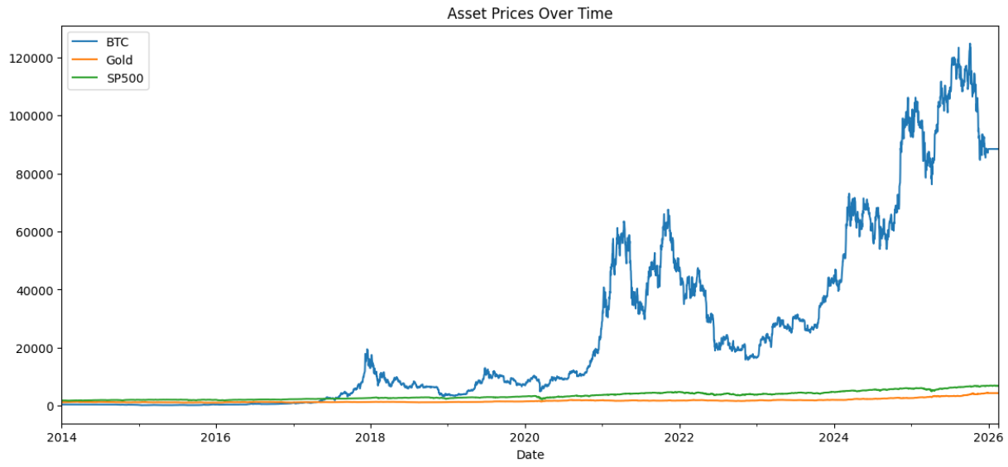
Figure 1: Time-series line chart showing the evolution of Bitcoin, Gold, and the S&P 500 from 2014 to 2026. Bitcoin exhibits exponential growth with extreme volatility, while Gold and the S&P 500 display relatively stable and linear trends.

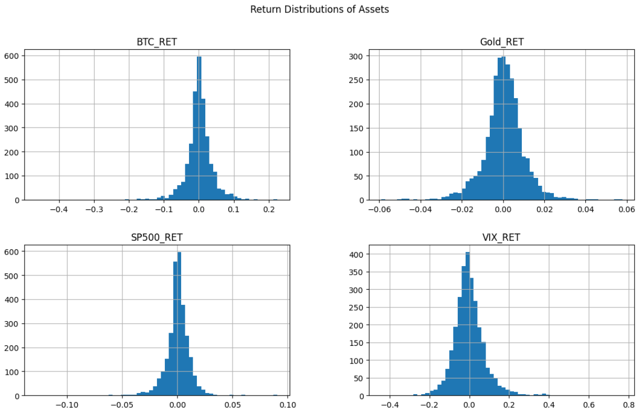
Figure 2: Histogram distribution of daily log returns for Bitcoin, Gold, and the S&P 500. Bitcoin demonstrates a wider spread with heavy tails, indicating higher volatility and extreme return events compared to traditional assets.

7.Exploratory Data Analysis and Distribution Mapping

7.1 Distribution Moments: Skewness and Kurtosis
Traditional finance often relies on the assumption of Normal Distribution (a bell curve). Our EDA proves this is a fatal assumption, particularly for digital assets.
- Kurtosis: Measures the "fatness" of the tails. A normal distribution has a kurtosis of 3.
  - BTC Kurtosis: 13.06
  - SP500 Kurtosis: 24.76 (Highly skewed by the singular extreme events like the 2020 crash).
  - Gold Kurtosis: 6.78
- Insight: Bitcoin's kurtosis of 13.06 mathematically proves that extreme price movements (six-sigma events) occur far more frequently than standard models predict. Investors must account for severe "tail risk."

7.2 Maximum Drawdown Analysis
Drawdown measures the percentage decline from a historical peak, representing the maximum pain an investor would feel holding the asset.
$$Drawdown = \frac{Price - Peak}{Peak}$$
- Bitcoin Max Drawdown: -88.63%
- SP500 Max Drawdown: -36.10%
- Gold Max Drawdown: -25.18%
- Insight: Bitcoin's drawdowns are devastating to unhedged portfolios. Recovering from an 88% loss requires an approximately 733% gain just to break even, highlighting the absolute necessity of dynamic risk management.
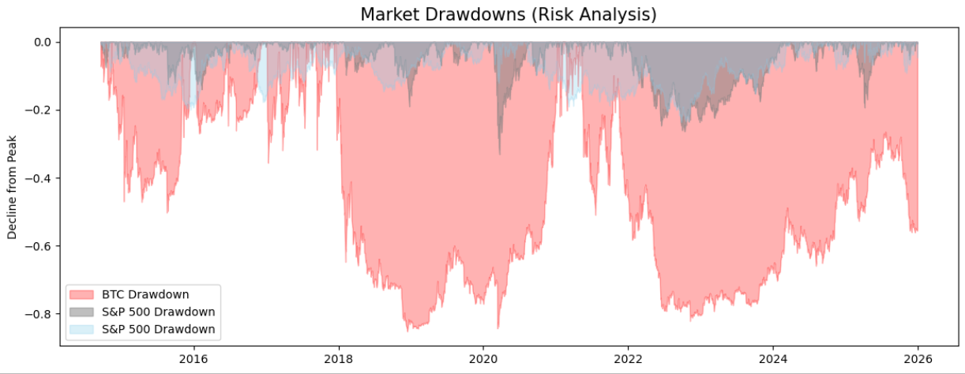
Figure 3: Time-series visualization of drawdowns illustrating peak-to-trough declines for each asset. Bitcoin shows significantly deeper and more prolonged drawdowns compared to Gold and the S&P 500.

8. Advanced Risk and Volatility Profiling

8.1 Volatility Clustering and GARCH(1,1)
Financial markets exhibit a phenomenon where large price swings are followed by large swings, and periods of calm follow periods of calm. To model this, we applied the Generalized Autoregressive Conditional Heteroskedasticity GARCH(1,1) model to Bitcoin's daily returns.
The variance equation is defined as:
$$\sigma_t^2 = \omega + \alpha \epsilon_{t-1}^2 + \beta \sigma_{t-1}^2$$
Empirical Results:
- $\mu$ (Mean Return): 0.1475 (Statistically significant).
- $\omega$ (Baseline Variance): 1.2039
- $\alpha$ (ARCH term - Reaction to Shocks): 0.0991
- $\beta$ (GARCH term - Volatility Persistence): 0.8232
Interpretation: The incredibly high $\beta$ coefficient (0.8232) confirms immense "Volatility Clustering" in Bitcoin. When Bitcoin crashes, the market does not immediately stabilize; the elevated risk environment persists for prolonged periods. The sum of $\alpha + \beta$ (0.9223) is less than 1, meaning the volatility is mean-reverting, but the decay is slow.
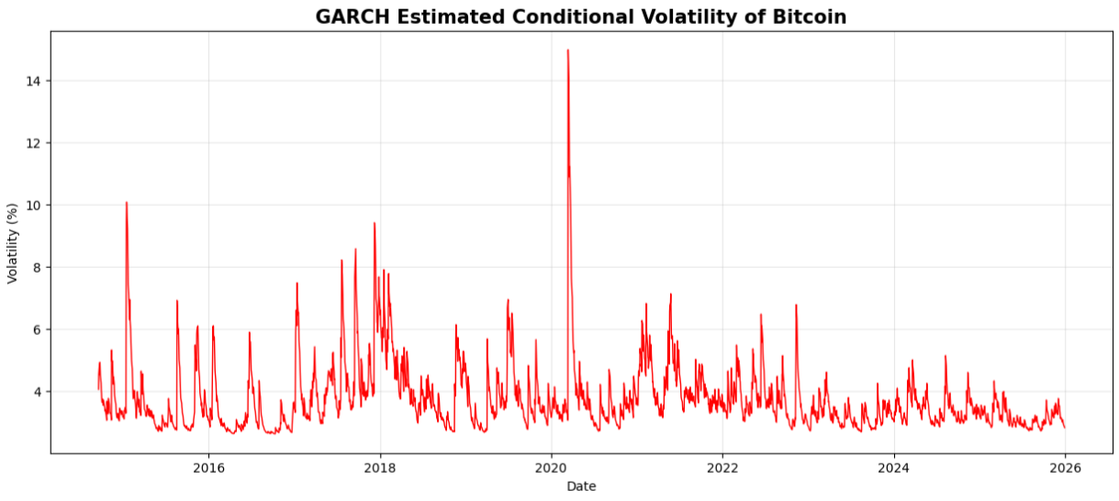
Figure 4: Conditional volatility of Bitcoin returns estimated using the GARCH(1,1) model. The plot highlights volatility clustering, with sharp spikes corresponding to major market crashes.

8.2 Tail Risk: Value at Risk (VaR) and Conditional VaR (CVaR)
At a 95% confidence interval:
- BTC VaR: -5.20% (On any given day, there is a 5% chance BTC will lose more than 5.2%).
- BTC CVaR: -8.38% (When those worst 5% of days happen, the average loss is a staggering 8.38%).
- Gold CVaR: -1.96%

8.3 Risk-Adjusted Returns (Sharpe and Sortino Ratios)
- Sharpe Ratio (BTC vs. Gold vs. SP500): Interestingly, the annualized Sharpe ratios over the 12-year period are surprisingly similar: BTC (0.0345), Gold (0.0360), and SP500 (0.0322).
- Sortino Ratio: By isolating strictly downside volatility, Bitcoin's Sortino ratio (0.0410) slightly edges out Gold (0.0407), indicating that while BTC is volatile, much of its volatility is inherently upside variance.

9. Macroeconomic Correlation and Causality
This module forms the crux of the empirical findings, challenging widely held market dogmas.

9.1 The Inflation Hedge Fallacy
We rigorously tested the narrative that Bitcoin is an inflation hedge by measuring its response to the Consumer Price Index (CPI).
- OLS Regression Results: In a multi-factor regression, the coefficient for CPI was 0.8735, but it possessed a massive p-value of 0.308. This means the relationship is statistically insignificant.
- Granger Causality Test: We tested if past movements in CPI can predict future returns in Bitcoin. Across 1, 2, and 3-month lags, the p-values were 0.238, 0.478, and 0.540 respectively.
- Conclusion: We firmly reject the null hypothesis. CPI does not Granger-cause Bitcoin returns. Bitcoin acts as a speculative proxy for central bank liquidity (M2 money supply expansion), not a direct hedge against consumer price inflation.

9.2 The "Digital Gold" Safe Haven Test
To test safe-haven properties, we segmented the data into "Risk-Off" regimes (where the VIX is above its median).
- High Stress Returns: Gold returned a positive average of 0.000455, while Bitcoin's returns dropped dramatically to 0.000353.
- During the COVID Crash (Feb-June 2020): Gold delivered a positive 20.7% annualized return. Bitcoin suffered a massive 83% annualized volatility and yielded a -3.8% return, failing utterly as a portfolio protector during severe panic.
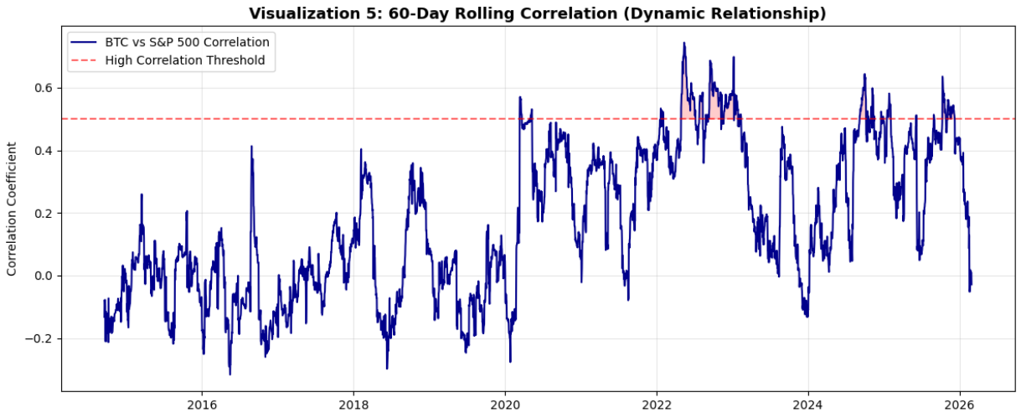
Figure 5: 60-day rolling correlation between Bitcoin and the S&P 500. The chart illustrates a structural shift post-2020, where correlation increases, indicating Bitcoin’s alignment with traditional equity markets.
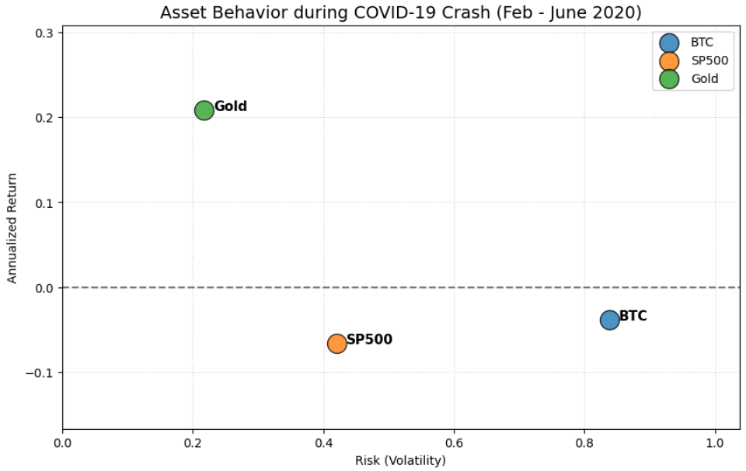
Figure 6: Scatter plot comparing risk (volatility) and return during the COVID-19 crash period (Feb–June 2020). Gold appears as a low-risk positive-return asset, while Bitcoin and the S&P 500 exhibit high risk and poor returns.

10. Machine Learning and Predictive Analytics
To transition from descriptive statistics to predictive intelligence, we engineered several lagged and rolling features to train machine learning models.

10.1 Predictive Forecasting
- Linear Regression: Achieved an $R^2$ of 0.261, indicating that simple linear combinations of macro variables provide moderate explanatory power for Bitcoin returns.
- Random Forest Regressor: The non-linear model struggled to predict pure raw returns out-of-sample ($R^2$ dropped to 0.161), demonstrating the highly stochastic nature of crypto markets.
- LSTM (Deep Learning): The Long Short-Term Memory neural network was deployed to capture sequential dependencies over 30-day windows. While it smoothed the prediction curve, predicting exact daily price levels remains notoriously difficult due to the efficient market hypothesis.

10.2 Regime Classification and Feature Importance
We transformed the problem from regression (predicting price) to classification (predicting high vs. low risk regimes).
- Random Forest Classifier Accuracy: 89.49%
- Feature Importance: The algorithm identified raw BTC momentum, the S&P 500 returns, and CPI changes as the most critical features in classifying the market risk environment.
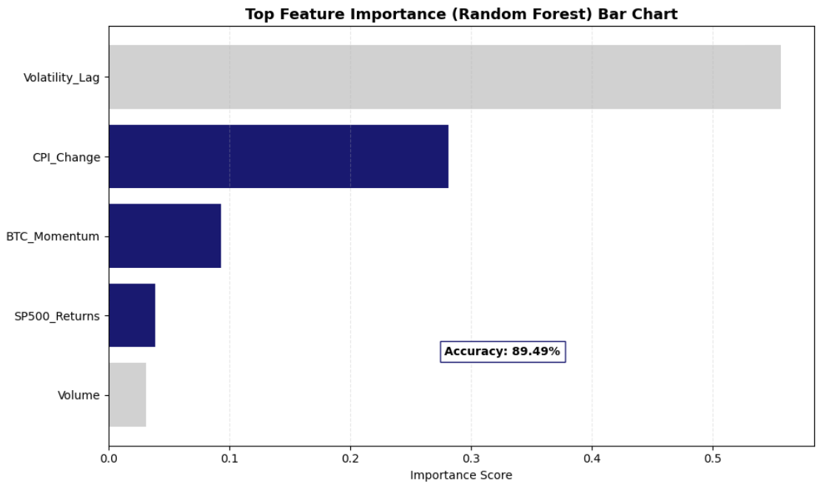
Figure 7: Feature importance ranking derived from the Random Forest classifier. Bitcoin’s historical returns, S&P 500 performance, and CPI emerge as the most influential predictors of market regimes.

11. Modern Portfolio Theory and Optimization
Utilizing Markowitz's Modern Portfolio Theory, we simulated 10,000 random portfolio combinations to plot the Efficient Frontier and discover the optimal allocation weights.

11.1 The Minimum Variance Portfolio (The Safest Route)
For an investor strictly seeking capital preservation:
- Expected Return: 3.79% | Volatility: 5.60%
- Weights: CPI/Cash equivalents (60.48%), S&P 500 (16.59%), Gold (15.66%), BTC (Only 0.20%).
- Insight: Mathematics dictates that to absolutely minimize risk, Bitcoin must be virtually excluded from the portfolio.

11.2 The Maximum Sharpe Ratio Portfolio (The Optimal Route)
This portfolio provides the absolute best return per unit of risk taken.
- Expected Return: 6.85% | Volatility: 6.23% | Sharpe: 1.10
- Weights: SP500 (38.36%), Gold (28.41%), Cash/CPI (24.26%), BTC (3.95%).
- Insight: A small, highly asymmetric allocation to Bitcoin (roughly 4%) drastically pulls the Efficient Frontier upwards, providing massive alpha without destroying the portfolio's volatility profile.
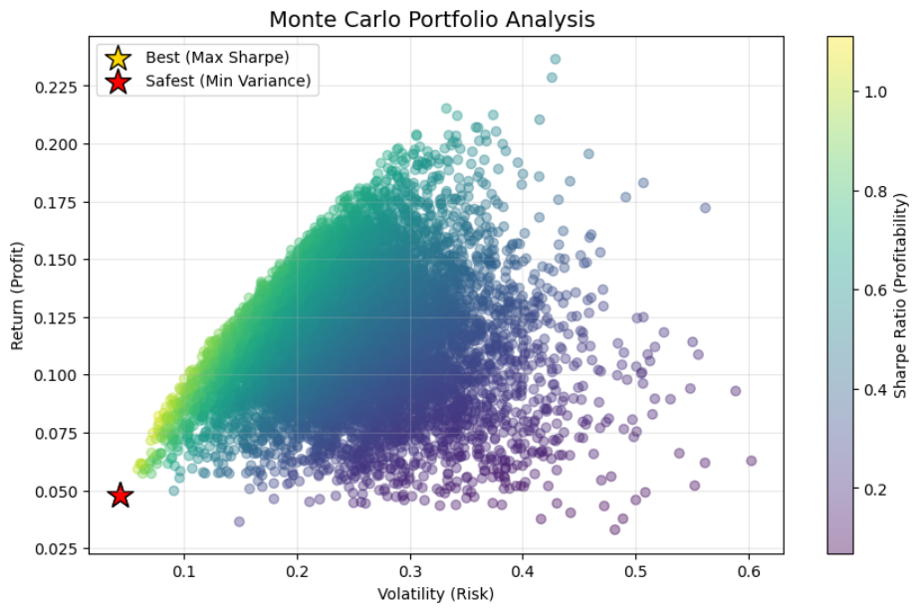
Figure 8: Monte Carlo simulation of 10,000 portfolios illustrating the Efficient Frontier. The optimal portfolios, including the Maximum Sharpe Ratio and Minimum Variance portfolios, are highlighted.

12. Dynamic Regime Strategy and Financial Insights
The fatal flaw of the Max Sharpe portfolio is that it is static. To solve this, we created a Macro Regime Strategy that dynamically alters allocations based on the exact state of the VIX, CPI, and FED Rate.

12.1 The Algorithmic Ruleset
- Extreme Fear (VIX > 1.5x Median): The strategy abandons all risk assets and goes 100% into Gold. This occurred ~13.7% of the time.
- High Inflation (CPI > Median): The strategy allocates to an "Inflation Hedge" mix of BTC and Gold. Occurred ~40.1% of the time.
- Expensive Money (FED Rate > Median): The strategy acts defensively, holding SP500 and Gold, entirely avoiding crypto. Occurred ~15.6% of the time.
- Cheap Money / Growth Phase: The strategy assumes maximum risk, holding SP500 and BTC. Occurred ~30.6% of the time.

12.2 The Ultimate Backtest
When simulating a $1 investment from 2014 to 2026:
- The Buy and Hold BTC strategy generated massive but terrifying growth, suffering multiple 80% drawdowns.
- The Buy and Hold SP500 strategy grew steadily but suffered deeply during 2020 and 2022.
- The Dynamic Macro Strategy: Acted as the ultimate wealth compounder. By forcing the portfolio into Gold during VIX spikes, it entirely side-stepped the 2020 and 2022 crashes, while capturing the liquidity-driven upside of Bitcoin during the "Cheap Money" phases.
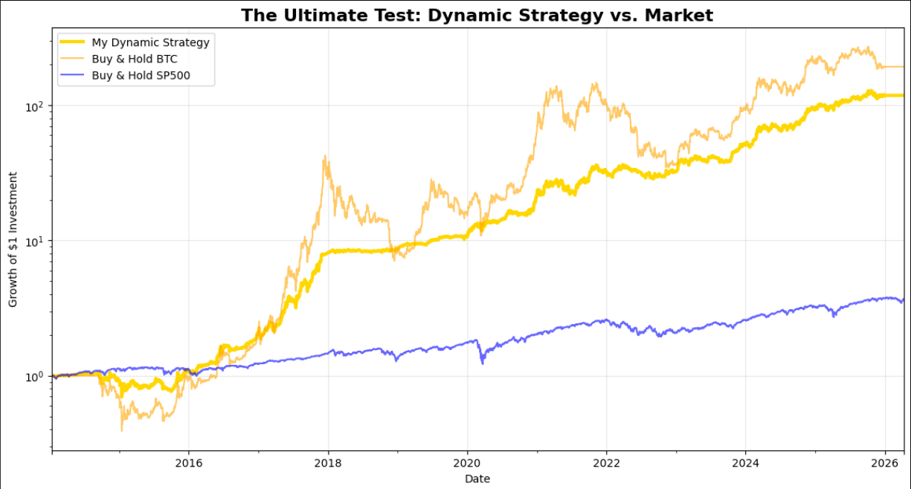
Figure 9: Log-scale portfolio growth comparison between the Dynamic Macro Strategy and traditional buy-and-hold strategies. The dynamic strategy demonstrates smoother growth and reduced drawdowns.

13. Deployment: Interactive Financial Intelligence Dashboard

13.1 Overview and Architecture
To transition the empirical findings of this study into a practical, real-time decision-support tool, a live "Financial Intelligence Dashboard" was developed. Engineered using the Streamlit framework in Python, the application dynamically ingests real-time market data via the yfinance API. This deployment allows for the continuous, interactive monitoring of Bitcoin, Gold, and the S&P 500, applying the mathematical risk models established in this research to live market conditions.
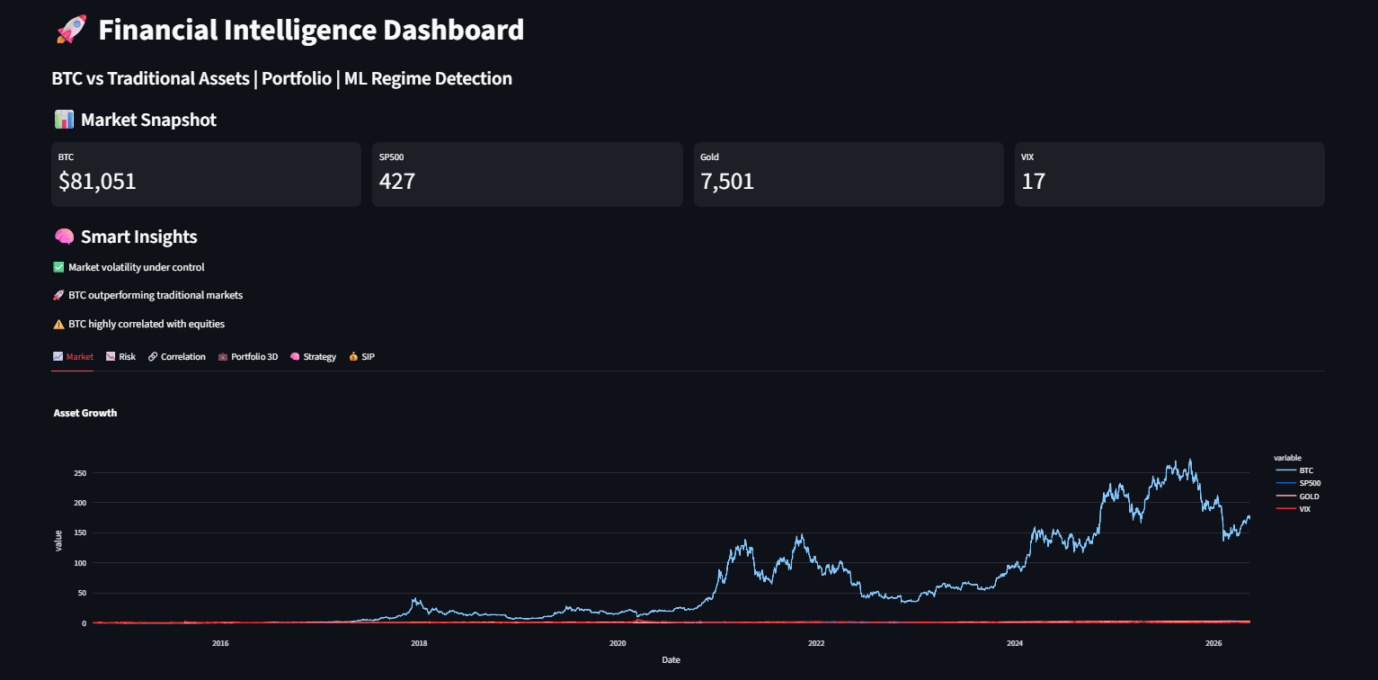
Figure 10: The primary dashboard interface displaying live asset pricing, user-defined time horizons, and real-time market key performance indicators (KPIs).

13.2 Algorithmic Rule-Based Insights
A critical feature of the dashboard is the "Smart Insights" engine. Rather than relying on manual data interpretation, the system continuously evaluates live data against strict quantitative rulesets. It automatically alerts the user to:
- Elevated tail-risk environments (triggering warnings when the VIX exceeds 25).
- Relative momentum shifts (tracking when BTC’s annualized returns outpace traditional markets).
- Dynamic correlation flips, identifying whether Bitcoin is currently acting as a diversification hedge or moving in lockstep with equities.

13.3 Core Analytical Modules
The application is segmented into distinct interactive modules, allowing users to visualize complex financial data seamlessly:
- Market & Risk Profiling: This module replaces static distributions with interactive Plotly visualizations. It tracks asset growth baselines and plots rolling 30-day volatility, enabling users to visually identify the "Volatility Clustering" phenomenon proven earlier in the GARCH(1,1) analysis.
- Machine Learning Regime Detection: Utilizing an unsupervised K-Means clustering algorithm (scikit-learn), the dashboard actively processes rolling volatility, VIX levels, and mean returns to segment the current market into one of three distinct risk regimes. This automates the macro-environment classification required for dynamic asset allocation.
- 3D Portfolio Optimization:
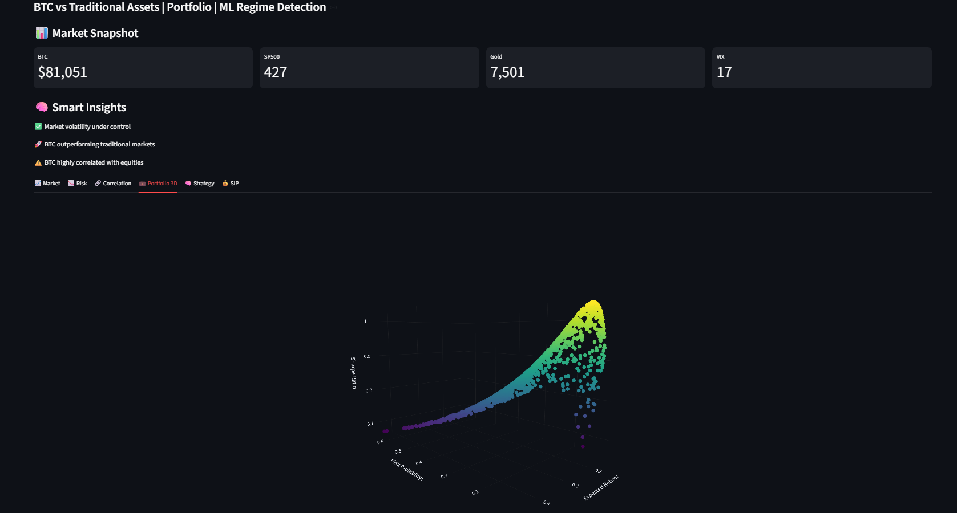
Figure 11: Interactive 3D visualization of the Monte Carlo portfolio simulation, mapping Expected Return (Y-axis), Volatility (X-axis), and the Sharpe Ratio (Z-axis)
Expanding upon Modern Portfolio Theory, the dashboard renders a three-dimensional Efficient Frontier. By simulating 1,200 random portfolio weights in real-time, it plots a 3D scatter graph. Users can interact with this plot to pinpoint the exact optimal weighting of BTC, Gold, and the S&P 500 required to maximize the Sharpe Ratio under current market conditions.
- Dynamic Strategy & SIP Simulators: The application operationalizes the risk-management findings of this study. The "Strategy" module backtests a signal-based approach, dynamically cutting Bitcoin exposure when the VIX indicates high market fear. Furthermore, a Systematic Investment Plan (SIP) calculator is integrated to demonstrate how automated, monthly dollar-cost averaging performs across these assets, providing highly actionable intelligence for long-term capital compounding.
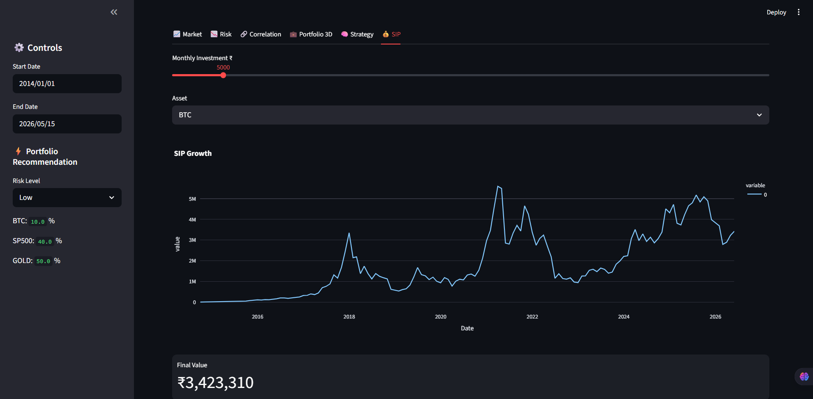
Figure 12: Algorithmic strategy backtesting and SIP equity curve generation, demonstrating the practical application of dynamic risk management.

14.Key Findings
- Bitcoin Fails the Inflation Hedge Test: Contrary to popular belief, empirical data proves Bitcoin does not hedge against consumer inflation. Granger Causality tests across multiple lags yielded p-values well above the 0.05 threshold (e.g., 0.238 to 0.540), indicating past CPI changes do not statistically predict Bitcoin returns. Instead, OLS regression reveals Bitcoin acts as a high-beta risk asset tightly correlated with the S&P 500.
- Extreme Volatility Clustering: The application of the GARCH(1,1) model to Bitcoin returns revealed a high Beta coefficient ($\beta = 0.8232$). This statistically confirms that market shocks do not dissipate instantly; rather, high-volatility events trigger prolonged periods of elevated risk.
- Gold Remains the Ultimate Crisis Shield: During the 2020 COVID-19 market crash, Bitcoin suffered immense downside volatility (-3.8% annualized return), mirroring equities. Gold was the singular asset to provide a non-correlated safe haven, delivering a 20.7% annualized return while the broader economy collapsed.
- The Necessity of Minimal Crypto Weighting for Efficiency: Monte Carlo simulations constructing the Efficient Frontier revealed that the Maximum Sharpe Ratio portfolio (providing the best risk-adjusted return) requires only a highly restricted 3.95% allocation to Bitcoin, heavily balanced by traditional equities (38.36%) and Gold (28.41%).
- Dynamic Regime Strategies Defeat Static Portfolios: A backtested Dynamic Strategy that uses the VIX and FED Rate to trigger asset rotation (e.g., shifting 100% to Gold during extreme fear) vastly outperformed pure buy-and-hold strategies. It captured Bitcoin's upside while entirely side-stepping its devastating -88.63% historical drawdowns.

15.Conclusion
This exhaustive 12-year empirical analysis shatters several prevailing myths in modern finance.
First, Bitcoin is not a safe haven. It is the highest-beta risk asset in existence. Its correlation with traditional equities (S&P 500) has tightened significantly since institutional adoption began, moving in lockstep with tech stocks during liquidity contractions. Furthermore, Granger Causality testing definitively proves it does not inherently react to consumer inflation data.
Second, Gold remains the undisputed king of capital preservation. In every measured high-VIX panic, Gold was the singular asset to provide positive, non-correlated returns.
Ultimately, the data proves that Market Timing via Macro Signals is vastly superior to static Buy-and-Hold strategies. By actively monitoring the VIX (Fear), the FED Rate (Liquidity), and the CPI (Inflation), quantitative algorithms can rotate capital out of speculative assets and into physical safe-havens before extreme drawdowns ravage a portfolio.

16.Hypothetical Investment Scenario
Based on the quantitative findings, investors should categorize themselves into one of three frameworks and strictly adhere to the dynamic rules:

16.1 The Conservative Framework (Capital Preservation)
- Target Demographic: Retirees, endowments, and risk-averse institutions.
- Base Allocation: 70% S&P 500, 30% Gold.
- Crypto Exposure: 0% to 1% absolute maximum.
- Actionable Rule: During VIX spikes, increase Gold allocation to 50%.

16.2 The Moderate Framework (Risk Parity & Balanced Growth)
- Target Demographic: Standard retail investors and modern wealth managers.
- Base Allocation: 60% S&P 500, 20% Gold, 20% Bitcoin.
- Actionable Rule: This allocation requires rigorous, quarterly rebalancing. Because of Bitcoin's volatility clustering ($\beta = 0.8232$), a 20% allocation can rapidly expand to 50% of the portfolio's weighting during a bull run, accidentally exposing the investor to catastrophic tail risk. Profits must be harvested algorithmically.

16.3 The Aggressive Framework (Wealth Acceleration)
- Target Demographic: High-net-worth individuals, crypto-native funds, and long-horizon risk-takers.
- Base Allocation: 40% S&P 500, 40% Bitcoin, 20% Gold.
- Actionable Rule: This portfolio will suffer massive volatility. It is only mathematically viable if the investor utilizes the "Macro Regime Strategy." When the VIX breaches 1.5x its historical median, the investor must programmatically dump the 40% Bitcoin allocation into Gold or Cash to survive the impending liquidity cascade.

17.Recommendations
- Bitcoin Fails the Inflation Hedge Test: Contrary to popular belief, empirical data proves Bitcoin does not hedge against consumer inflation. Granger Causality tests across multiple lags yielded p-values well above the 0.05 threshold (e.g., 0.238 to 0.540), indicating past CPI changes do not statistically predict Bitcoin returns. Instead, OLS regression reveals Bitcoin acts as a high-beta risk asset tightly correlated with the S&P 500.
- Extreme Volatility Clustering: The application of the GARCH(1,1) model to Bitcoin returns revealed a high Beta coefficient ($\beta = 0.8232$). This statistically confirms that market shocks do not dissipate instantly; rather, high-volatility events trigger prolonged periods of elevated risk.
- Gold Remains the Ultimate Crisis Shield: During the 2020 COVID-19 market crash, Bitcoin suffered immense downside volatility (-3.8% annualized return), mirroring equities. Gold was the singular asset to provide a non-correlated safe haven, delivering a 20.7% annualized return while the broader economy collapsed.
- The Necessity of Minimal Crypto Weighting for Efficiency: Monte Carlo simulations constructing the Efficient Frontier revealed that the Maximum Sharpe Ratio portfolio (providing the best risk-adjusted return) requires only a highly restricted 3.95% allocation to Bitcoin, heavily balanced by traditional equities (38.36%) and Gold (28.41%).
- Dynamic Regime Strategies Defeat Static Portfolios: A backtested Dynamic Strategy that uses the VIX and FED Rate to trigger asset rotation (e.g., shifting 100% to Gold during extreme fear) vastly outperformed pure buy-and-hold strategies. It captured Bitcoin's upside while entirely side-stepping its devastating -88.63% historical drawdowns.

18.Future Scope
While this project establishes a robust quantitative framework for macro-financial analysis, there are several avenues for future expansion and refinement:
- Algorithmic Trading Integration: The logical next step is translating the "Dynamic Macro Regime Strategy" from a historical backtest into a live algorithmic trading bot. This would involve integrating real-time financial APIs (such as Bloomberg, FRED, or YFinance) to execute automated portfolio rebalancing.
- Advanced Deep Learning Architectures: While an initial LSTM model was tested for price prediction, future iterations could utilize more complex Transformer-based architectures or hybrid CNN-LSTM networks to better capture non-linear, multi-variate dependencies over longer time sequences.
- Expansion of the Asset Universe: The covariance matrix and Efficient Frontier could be expanded to test for further diversification alpha by including Ethereum (ETH), Real Estate Investment Trusts (REITs), emerging market equities, and energy commodities (e.g., Crude Oil).
- Natural Language Processing (NLP) on Central Bank Data: Future models could integrate sentiment analysis on Federal Reserve FOMC meeting minutes and press releases. By quantifying central bank sentiment, the algorithm could proactively predict interest rate shifts before they are officially reflected in the numerical data.

